

Final Paper

Public Schools Enrollment in Massachusetts in 2018

GIS5130 21191 Foundation of Geographic Information System – Winter 2020

Instructor: James Armstrong (Prof.)

Created by Thi Thai Ngan Le (Crystal)

**Contents**

**1. Problem Overview.** 3

**2. Dataset Overview.** 3

**3. GIS methods and tools.** 3

**4. Analysis and Visualizations** 4

**5. Conclusion** 4

**References** 4

# **1. Problem Overview.**

Public school and number enrollment are concerned by parents, students and employees in the secondary education sector. This paper will visualize the number of enrollments in public schools in Massachusetts in 2018 in the map. It also shows the is about to visualize the data about students and teachers of public school in Massachusetts. Here are the research question:

Which school and which city has the most enrolment and most number of public school in MA?

Which city and which school have the highest teachers’ salary?

# **2. Dataset Overview.**

The data is retrieved from Kaggle by the link <https://www.kaggle.com/ndalziel/massachusetts-public-schools-data#MA_Public_Schools_2017.csv>

The dataset provides information about all publics and charter schools in Massachusetts updated in August 2017 including details about schools (names, type of school, address, contact, enrollments, so on), about students (firsts language, races, gender, performance in SAT, MCAS results, %graduation, so on), costs and salaries for teachers, class sizes, accountability report, and other relating factors about schools.

There are 302 columns with 1861 records but

In this project, I am using some specific columns comprising “Number of Students”, “Address 1”, “Town”, “State”, “Zip”, “District”, “Average Salary”.

# **3. GIS methods and tools.**

The map of MA will be created based on the Google Map of HCMGIS in assignment week 5. The location of school will be shown in the map, so it can be seen that which city has more public schools. This can be shown using QGIS.

The summary of teacher salary and student enrolment can be shown using Selection Statistics in week 4 assignment.

The number of student can be shown in color by the amount

There is an issue when I tried to geocode the address to QGIS platform. It limits to 2,500 records within 24 hours for using geocoding service of Google. However, with 1,861 records, the system keep returning the #429 errors alarming that there are too many requests.

# **4. Analysis and Visualizations**

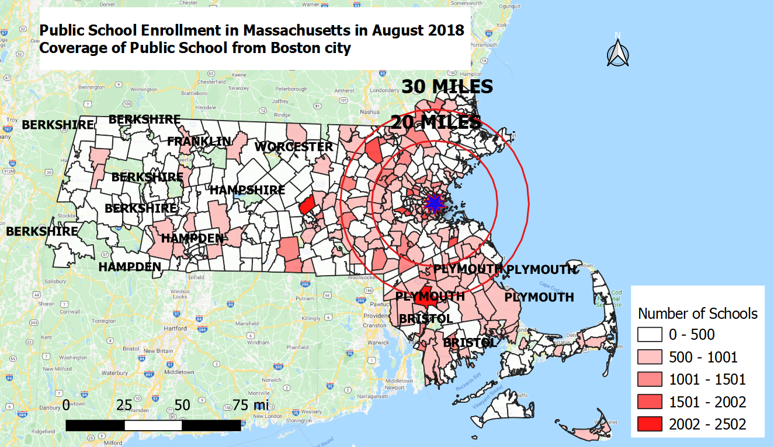

# **5. Conclusion**

# **References**

Piccoli, G. and Pigni, F (2016). *Information Systems for Managers: With Cases, (3rd).* Prospect Press. ISBN: 978-1-9431-5305-3.Retrieved on 21 February 2020

Ahmen Mahmoud. (2020). *Customer Experience Strategy for hotels and how it can Generate More Revenues*. Retrieved from <https://www.hospitalitynet.org/opinion/4069852.html>